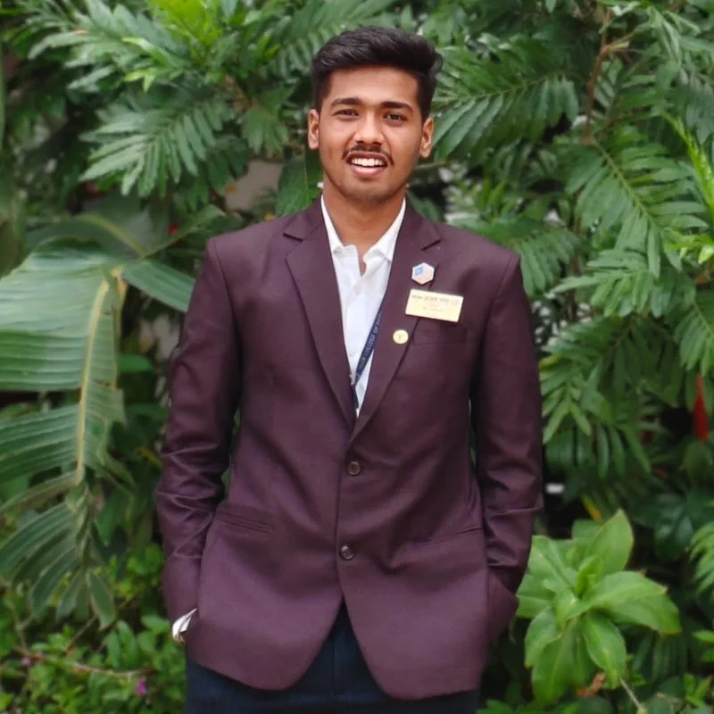

Profiles
0 Linkedln
Aditya Patil
Aditya
AI Developer | Multi-Agent Orchestration | RL & Cognitive Architectures | IEEE Chair 2026
adityavpatil818@gmail.com +91 815284 5070 JCER BELGAUM

Summary
Highly technical AI Developer & IEEE Student Branch Chair (2026) with a focus on Multi-Agent Orchestration, Reinforcement Learning, and Applied Cognitive Architectures. Proven track record of building production-ready AI environments (SupportEnv) and long-term memory systems (AISERS). Expert in full-stack development using React, FastAPI, and Supabase, combined with strategic leadership of high-impact technical communities.

Education
PES Pre University College
Science (PCMCs) https://pestrust.edu.in/pesitm/
Jain College of Engineering and Research
Computer Science and Engineering (AIML) https://jcer.in
Volunteer
IEEE NKSS
North Karnataka Sub-Section

PUC • Distinction Shivamogga • 2 Years

B.Tech • 7.7 CGPA
Belgaum • 3 years

2025-2026

Worked as Co-Lead in technical committee, Students Association Committee (SAC) under IEEE North Karnataka Subsection (NKSS), organizing and managing technical activities, student life and volunteer functions throughout the region.

Skills
 Languages  AI/ML Frameworks  Full-Stack & Backend

Python, SQL, Bash, C/C++, TypeScript, JavaScript
LangChain, Transformers, HuggingFace, Scikit-Learn, Reinforcement Learning, CrewAI
React 18, Vite, FastAPI, Streamlit, Node.js, Supabase, Flask

 GitHub # Latex

Projects
MemoryForm
AI Long-Term Memory Engine
Developed a multi-agent cognitive architecture using FastAPI, React, and Supabase to provide AI agents with persistent, infinite-context memory. Integrated Sentence-Transformers and a custom weighted ranking algorithm (Similarity, Recency, Confidence) to solve LLM state-loss.
Tech Stack: React 18, FastAPI, Supabase (Vector Store), Docker, Sentence-Transformers (all-MiniLM-L6-v2), OpenRouter.
Bhasha AI
Multi-Agent Translation Pipeline
Architected a 6-agent translation workflow using LangGraph that handles technical glossary injection (Domain Optimization), cultural adaptation, and sentiment alignment for high-fidelity localization.
Tech Stack: LangGraph, LangChain, Transformers.
Disaster Management
Multi-Agent Emergency Orchestrator
Implemented a CrewAI-based response system coordinating five specialized agents for incident triage, casualty estimation, and resource management. Used BART and RoBERTa for real-time severity classification from live reports. Tech Stack: CrewAI, Streamlit, Hugging Face (BART, DistilBERT, RoBERTa), Pandas.
SupportEnv
Customer Support RL Environment
Built a production-grade Reinforcement Learning environment to train AI agents on high-stress support tickets, developing a modular sentiment-and-accuracy grader to provide stable reward signals for complex de-escalation workflows.
Tech Stack: FastAPI, RL Core (Stable Baselines3), Gradio UI, OpenEnv Speciﬁcation.
Visualization
WSN Sensor Deployment Framework
Developed a research-focused optimization tool using Gradient Field Greedy algorithms and Q-Learning to ensure 95%+ sensor coverage while maintaining connectivity thresholds for maximum network longevity in non-uniform terrains.
Tech Stack: Python, Streamlit, Q-Learning (RL), KD-Tree, LEACH/HEED Engines.
Cloud Research
Hybrid Cost-Optimization Engine
Achieved a 28% reduction in cloud over-provisioning costs by designing a hybrid predictive framework that accurately classifies machine workload types and automates scaling for large-scale data centers.
Tech Stack: Python, LSTM, ARIMA (Hybrid Engine), K-Means Clustering, Google Cluster Trace Data.
Elevare
AI-Driven Job Matching Platform
Engineered an end-to-end job matching platform featuring an automated ATS scoring engine and domain-specific recommendation system to provide personalized career roadmaps and real-time job opening updates.
Tech Stack: Vite, React, Flask, Gemini 2.5 Flash API, Supabase (Auth/DB), Vercel.
Paper2Code (ResearchGap Analyzer)
Designed an automated research productivity pipeline that analyzes scientific PDFs to identify methodological gaps and generate functional Python implementations to bridge identified technical deficiencies.
Tech Stack: Streamlit, Gemini Pro API, Patent Extractor Module, Regex Parsing.
SIH (Agri-Sethu)
Smart Crop Recommendation System
Developed a precision agriculture assistant for regional crop and fertilizer advice, integrating geospatial mapping to reduce fertilizer waste and improve yield prediction accuracy by 18%.
Tech Stack: Streamlit, Scikit-learn (Ensemble), MongoDB, SoilGrids API, ISRO Bhuvan Maps.
Arogya Saathi
Rural Health Companion
Built a multilingual healthcare assistant with Offline AI support for rural regions, providing digital medical triage, symptom assessment, and hospital recommendations without requiring high-speed internet.
Tech Stack: Streamlit, LangChain, BioMistral-7B, Ollama (Gemma 3), spaCy (NLP).
Livestack
Livestock Lifecycle Intelligence Engine
Designed an extensible intelligence engine for lifecycle tracking and health monitoring of livestock, utilizing data-driven monitoring blueprints to optimize farm efficiency and productivity.
Tech Stack: Python, Planning Blueprints, AI Analytics.

Experience
JCER IEEE STB
CHAIR
Leading a student branch for 2026 as the CHAIR for the student branch.
IEEE Bangalore Section SAC
Technical Committee (Member)

Belgaum 2026-2027

2026-2027

Working as volunteer in technical committee, Students Association Committee (SAC) under IEEE Bangalore Section, organizing and managing technical activities, student life and volunteer functions throughout the region.

Languages
English Kannada Hindi

Publications
Beyond Passwords: The Essence and Impact of Multi-Factor Authentication in Cybersecurity
IEEE

24-May-2024

This study explores MFA vulnerabilities, bypass techniques, and modern security solutions using adaptive AI. https://ieeexplore.ieee.org/document/11140909
AR and AI for Driver Assistance and Navigation
A comprehensive study on the synergy between Spatial Computing (AR) and Computer Vision (AI) aimed at revolutionizing Next-Gen Head-Up Displays (HUDs) and Autonomous Driving Systems for enhanced road safety and traffic efficiency.

